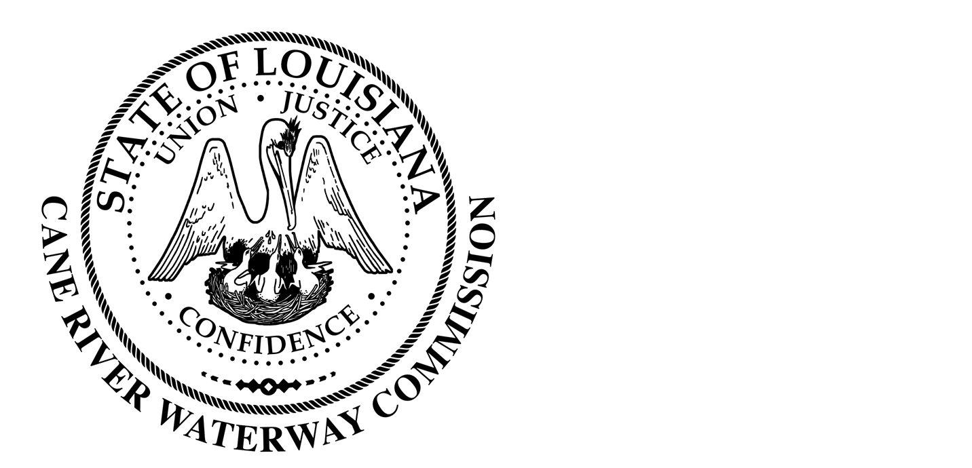
Cane River Waterway Commission
Minutes
November 15, 2022

There was a public hearing of the Cane River Waterway Commission on November 15, 2022 at 6:00 pm located at 244 Cedar Bend, Natchez, Louisiana.
The hearing was called to order and roll was called with the following members being present: Mr. Rhodes, Mr. Paige, Mr. Methvin, Mrs. Banks, Mr. Methvin and Mr. Wiggins.
Also present was Director of Operations Jason Adcock and Attorney Tommy Murchison.
The minutes of the regular meeting on October 18, 2022 were presented. The Chairman opened the floor to public comments and after discussion the Chairman closed the floor to discussion. Upon motion by Mr. Methvin seconded by Mrs. Banks and unanimous vote by Mrs. Banks, Mr. Paige, Mr. Rhodes, Mr. Methvin and Mr. Wiggins, the Commission approved the minutes of the October 18, 2022, meeting as written.
Mr. Adcock presented the Commission with the financial report from October 15-November 15, 2022. The Chairman opened the floor to public comment and after discussion the Chairman closed the floor to discussion. Upon motion by Mr. Wiggins, seconded by Mr. Paige and unanimous vote by Mr. Paige, Mr. Rhodes, Mr. Methvin, Mr. Wiggins and Mrs. Banks the Commission approved the financial report.
There being no further business to come before the Board, upon motion by Mr. Methvin seconded by Mr. Wiggins and unanimous vote by Mr. Wiggins, Mrs. Banks, Mr. Paige, Mr. Methvin and Mr. Rhodes, the meeting was adjourned.

________________________________
Approved by
__________________
Date

